**Ansible learning path**

|  |
| --- |
| * **Week 1** |

* 1. JTC - Red Hat Ansible Automation Platform (IBM Journey to Cloud)  
     <https://yourlearning.ibm.com/activity/ILB-EKREWPVYJYGM2X3R>
  2. Directlink to Redhat Ansible Essentials:
  3. <https://www.ansible.com/resources/webinars-training/introduction-to-ansible>
  4. YAML Beginner and Intermediate Level  
     <https://ec.yourlearning.ibm.com/w3/playback/10064410>

|  |
| --- |
| * **Week 2** |

* 1. Learning Path: Ansible: Ansible Automation Masterclass  
     <https://yourlearning.ibm.com/activity/SAFARI-9781789530834>
  2. Learn about repeatable and reliable end-to-end app provisioning and configuration. Use Red Hat Ansible for app deployment with IBM Cloud Schematics  
     <https://developer.ibm.com/articles/application-deployment-with-redhat-ansible-and-ibm-cloud-schematics/>
  3. Red Hat account creation and enrolment  
     i. For account creation refer following document,  
     Document Name: RedHat Partner Login creation.pdf  
     Url: <https://ibm.box.com/s/abo3e1edctuwb6c4c6dnqglcbypm0l5e>ii. Enrol for Red Hat Delivery Specialist – Automation  
     <https://training-lms.redhat.com/sso/saml/auth/rhopen?RelayState=deeplinkLP%3D40333271>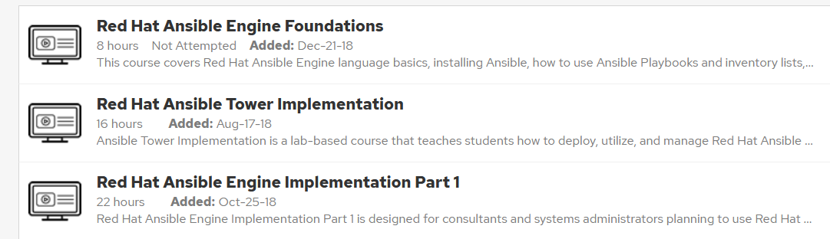  
       
     iii. Use following link to enrol Red Hat Ansible Engine Implementation Part 2   
     <https://www.redhat-partner.com/build/frontend/assets/RH_ISV_LearningPaths_Overview_ANSIBLE.pdf>